
Rice College Ennis (An Edmund Rice School)

Address: New Road, Co. Clare. V95 FV10 Tel: 065-6822105 Email: admin@ricecollege.ie Web: www.ricecollege.ie

Notification regarding the Board of Management’s annual review of the anti-bullying policy

To: All Relevant Bodies:

The Board of Management of Rice College Ennis wishes to inform you that:

  - The Board of Management’s annual review of the school’s anti-bullying policy and its implementation will be completed at the Board meeting of 17/6/26.

  - This review will be conducted in accordance with the checklist set out in Appendix 4 of the Department’s Anti-Bullying Procedures for Primary and Post-Primary Schools.

Signed Date: 17/6/26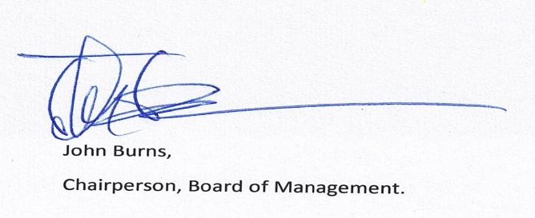

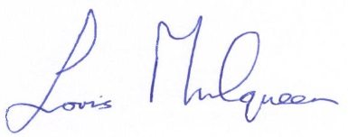
Signed _____________________________________ Date: 17/6/26
Principal

